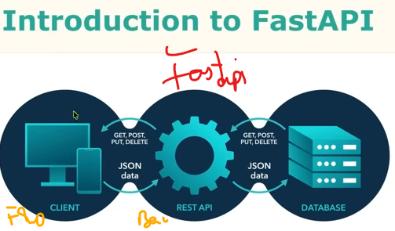
A complete User Interface (UI) to FastAPI to Database (DB) architecture relies on an asynchronous, unidirectional flow where data is collected/enter by the frontend/user, validated/checked by the backend [if validate than] committed/saved to storage/db
- Asynchronous: Request ke wait mein system unnecessarily block nahi hota.
- Unidirectional flow: Data ka normal direction UI → FastAPI → DB hota hai.
- Securely committed: Backend validation/security checks ke baad DB mein save hota hai.

Client/Frontend means Website/ App screen / UI screen
API is part/interface of Backend, that’s why they are not 2 separate layers
API: Bridge/Entry-Pt/Interface by which frontend can communicate with backend. frontend send req & backend give response, mostly in JSON form b/c it is lightweight & easy to use format for frontend.
Backend: the server-side system behind that bridge
Main purpose of API is data exchange
FastApi: Modern Python Web Framework used to made fast and efficient API's.
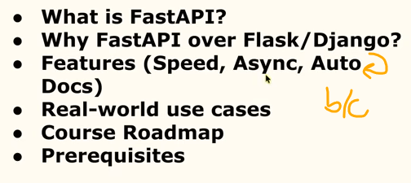
provide automatic api doc [for eg Auto Data Validation]for testing just run that url on browser no need of Postman so readymade doc support, give Swagger type/form UI
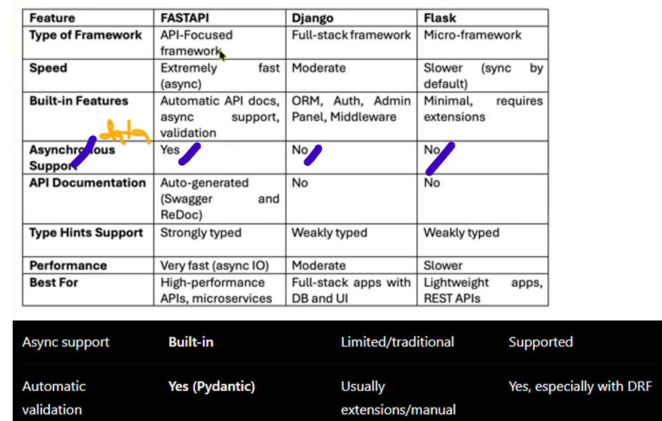

professionally project made in Venv, b/c each project python or api version can be different
b/c by venv, dependencies isolate [mtlb falah project m python or api ka ye version use krunga falah project etc]

Installation:
pip install fastapi [globally install]
pip install uvicorn [where u run the application so the server will be uvicorn]
pip install fastapi uvicorn [can do multiple installation just space separated]
pip list

Venv:
venv creation: python -m venv venv
venv activation: venv\Script\activate

Server Run Cmd:
M1] uvicorn filename:fastapi_object_var –reload
eg; if filename is main.py & FastAPI() obj var name is app
uvicorn main:app –reload
M2] python filename.py but after this addition:
import uvicorn
if __name__ == "__main__":
uvicorn.run("main:app", reload=True)
b/c here uvicorn.run() will start the server. W/O this, only FastAPI will create

1st create Route
Route: is a url path, where each route have some func attach to it & it exec/run whenever we visit that url. Route made as per page req, etc
Swaggers UI: Auto generated api doc tool to easily visualize/test api working w/o using postman
to use/see swagger ui: base_local_host url/doc

Jb hm http://127.0.0.1:8000 krte h tou yaha jo kuch nazar aata h wo api response/data h json form m. ye naa ke webpage h, html m render Frontend hi krta h

“route” and “API” are not exactly the same thing.
So for beginner-level understanding: 1 route/endpoint ≈ 1 API endpoint
Here you have 3 API endpoints:
GET /users → API endpoint
POST /users → API endpoint
GET /products → API endpoint
But don't say strictly: "1 route = 1 API"
because an API usually means the whole collection/interface of endpoints.

Think of it like this:
API
│
├── GET /users
├── POST /users
├── GET /products
└── DELETE /products/{id}
API = whole system/interface
Endpoint/Route = individual entry point
GET Request
GET Request: to get the data from the server
path parameter: url m jo bhi dynamic chg krni ho. Func same but on the base of inp[id] it behaves differently
/user/no
# When we does not mention any DT, then by default it assumes/is int. for eg here var name is id & its DT not mention

@app.get("/user/{id}")
def show(id):
return {'data':id}
Here in func, para is expected a value
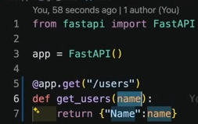 we does provide here, so error come:
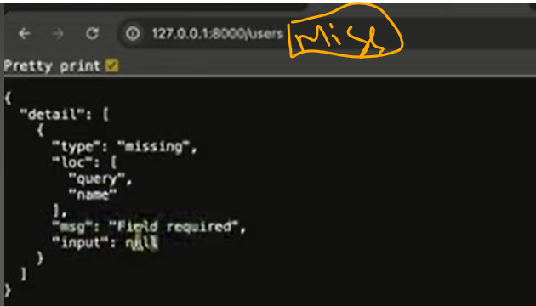
Either pass value using ? or set an Optional Parameter value

Query Parameter: ? is the sign of Query Para, these type of query[filter, search, pagination etc] handle by it .
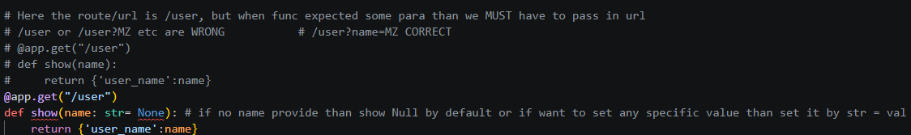
Multiple Query Parameter:
Jis para ki val milegi uski dikha dega jiski nhi uska null ya default val
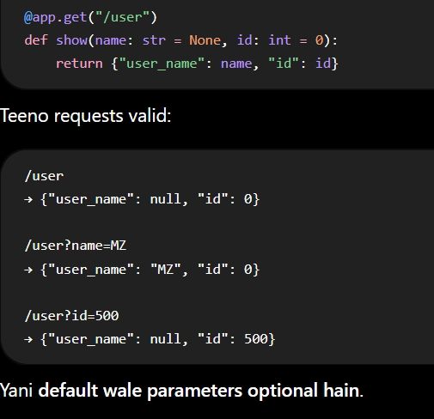

Mtlb koi bhi DT ho ,jb bhi val denge direct denge. Formal way m nhi. Jese str “” m hoti h liken yaha nhi
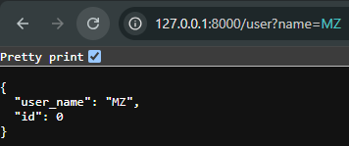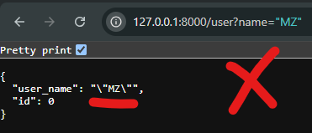
all-or-none ka case nahi hota h [if u have n no of para in the function of route than if anyone's value is set as default then it is must to set all para values as default]
Python mein ACTUAL rule ye hai:
Non-default parameter ko default parameter ke baad nahi rakh sakte +
Or Hamesha Har haal m Non-Default para ki value deni hoti h.
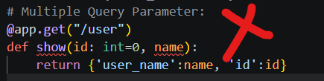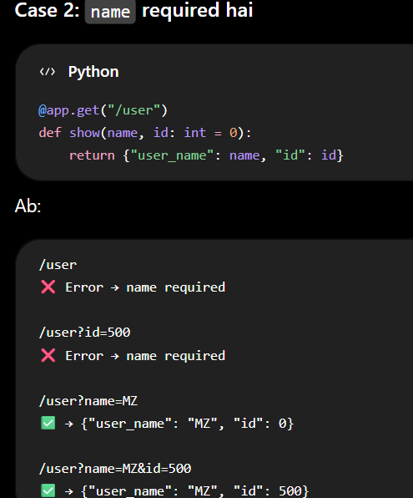

Must remember:
Name = “zeeshan” : str GALAT
Name : str = “zeeshan” : SAHI

REQUEST BODY: Data which client/user send to Backend [email, passw ,etc] in form of JSON
For new data creation, POST request required
Only GET HTTP method can be tested on browser, other HTTP method [PUT, POST, etc] can test on Swagger
These all HTTP method used in API

POST Request
1] Simple post method, and para are mention in function [so here comes Lim]
Benefit: data validation
Loss: Limited para & url is also changed
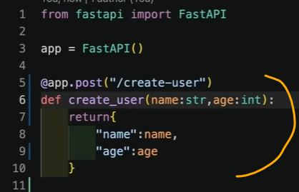
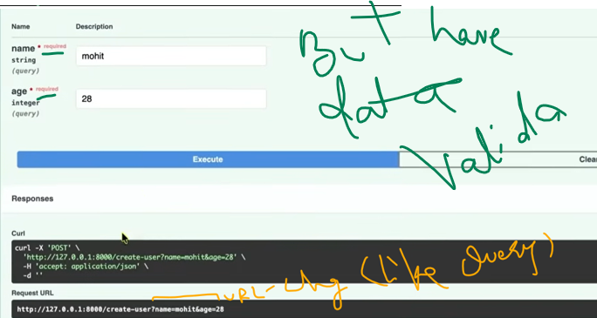
2] Now entire dic passed by the user:
Benefit: No para limit, url is valid
Loss: No data validation
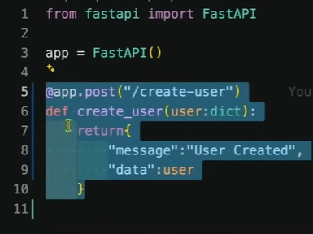
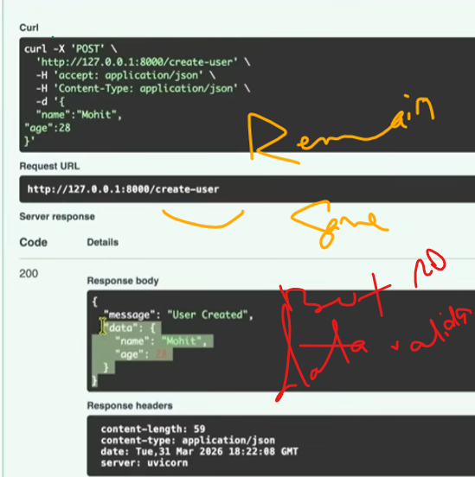

Now we want all 3 things at once [JSON/no para lim + data validation + url remain same] so:
PYDANTIC used
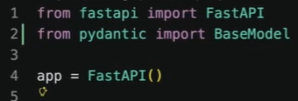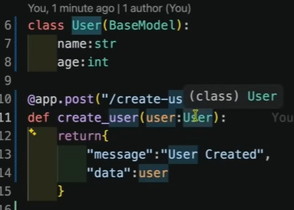

Pydantic vs Dict:
Auto validation No validation
Structure Flexible
Auto Error Hand Manual Error Handling
Pydantic Model:
Schema structure which defines the format of data
Tell how many no of field [eg; will have name, email. Then only these 2 fields can exist] are there & their detail[order], as field are defined earlier
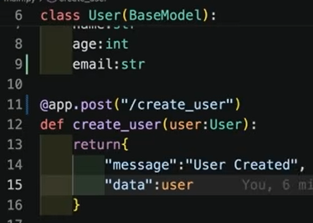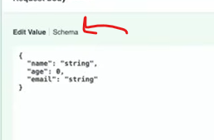
NESTED MODELS:
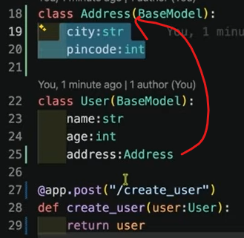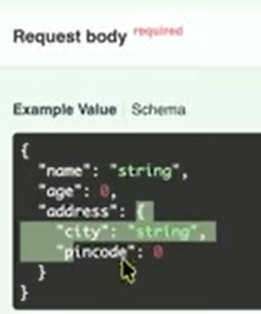
API CRUD using [GET, POST, PUT,DELETE & Pydantic]:
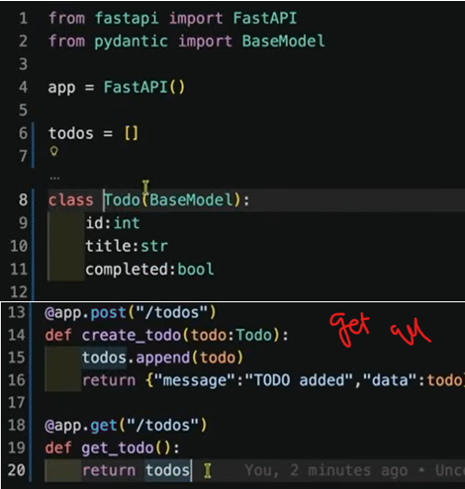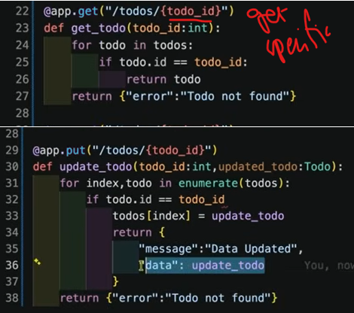

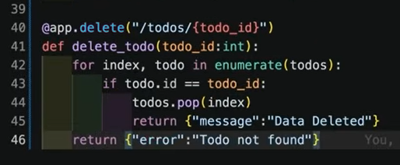
PUT vs PATCH
Complete data update Partial data updation

PRACTICE OF ALL LECTURE IN COMBINED FORM:

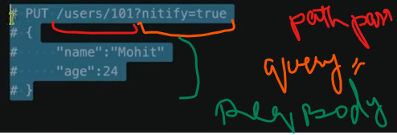

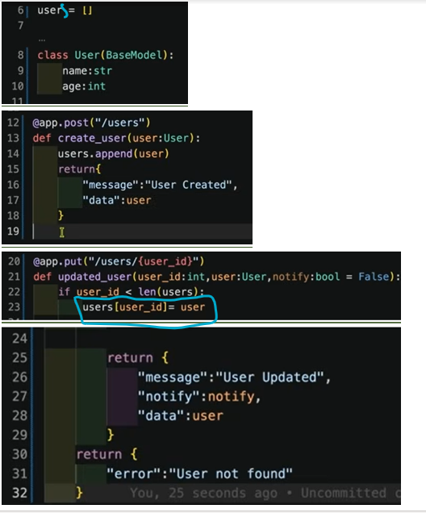
users = [] ← actual list/database-like storage
user: User ← ek individual User object
